*Trouble shooting appliance – stove*

If you find that your stove is not working, and you need to call in a repair request for the stove there are a few things to check on first.

1. First determine if you have a gas stove or electric stove. If you do not know there are a couple ways to investigate this:
   1. First look at the back of the stove and see what types of connections you have. It should look like one of these:

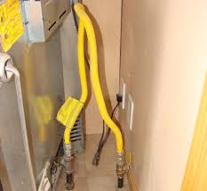 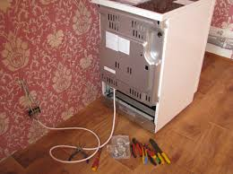

*Gas connection Electric connection*

1. If you have an electric stove, ensure that it is securely plugged into the wall. If the stove is plugged into the wall but still has no power, then check to make sure that there isn’t an electric breaker tripped. If you are unsure on how to check for a flipped electric breaker you can find how to do that in the CAP tenant resources section or click this link: <https://www.cincyareaproperties.com/tenantresources/how-to-reset-a-tripped-breaker>
2. If you have a gas stove, ensure that the gas service is turned on to your home. If gas is included with your rent, then notify CAP, if you are a new resident and gas is your responsibility then there is a chance that Duke only turned on the electric but may not have turned on the gas, so make sure first that you do have active gas service for your apartment.

If you have determined that the stove is plugged in, there is gas service and that there is no visible damage to the stove then it’s time to create the service issue and gather the following information:

1. Film a short video (under 90 seconds) of what the stove is doing. If it won’t turn on, heat etc. then film that. Also open the oven up and film the inside as well.
2. In addition to the video please describe as much as possible what is going on with the stove (Example oven not working, burner not working etc.). We may need to call you with additional questions.
3. Find the manufacturer on the stove, this is usually found on the top part of the stove in the left- or right-hand side.
4. If you can locate the model number, please send that as well. Here is a diagram showing where MOST model numbers are located. If you can locate it, please take a photo of it.

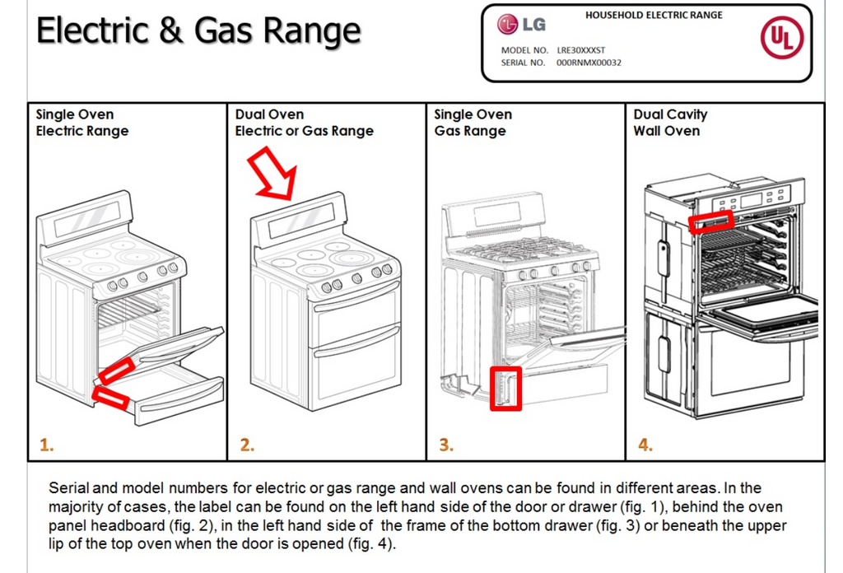

By doing these steps you can help C.A.P. resolve the issue with as minimal intrusions into your home as well as being efficient and effective. Thank you for your cooperation and we value your partnership with C.A.P.