Trouble shooting a Refrigerator

If you find that your refrigerator is not working properly, and you need to call in a repair request there are a few things to check on first:

1. Ensure that the refrigerator is plugged in and the power is on.
2. Check the door seals for damage
3. Verify that the temperature settings are correct
4. Check for any obstructions in the vents (exterior)
5. Check to make sure the refrigerator or freezer are not packed full. There should be some space between the items and the back of the wall (generally 1 – 2 inches of the space at the back of the unit and ½ to 1 inch of space on each side.

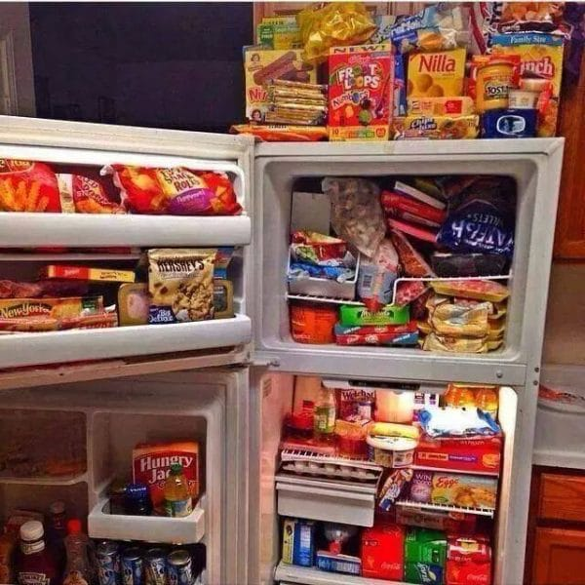 

**THIS IS WHAT NOT TO DO Proper way to pack your freezer**

After trouble shooting your refrigerator freezer and you need to make a service request do the following:

1. Take a video of the unit for less than 90 seconds. Make sure to open the refrigerator door, freezer door and capture any noises it is making.
2. Describe the problem in as much detail as possible. If the lights are coming on but it’s not cooling or freezing, make sure to tell that.
3. Locate the manufacturer’s name, which is usually on the front door.
4. Locate the model number and send that to us as well (see diagram).

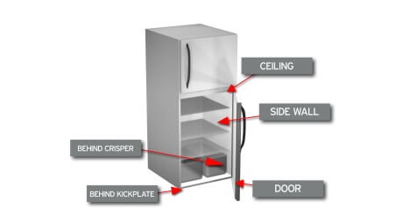

Once you have that information, please take a photo and send that photo of the model number along with the video and the description of the issue.

By doing these steps you can help C.A.P. resolve the issue with as minimal intrusions into your home as well as being efficient and effective. Thank you for your cooperation and we value your partnership with C.A.P.