
Making a rental payment via the tenant portal
You can access the tenant portal on the cap website and log in, your username and password are the email you used to apply online during the application process.
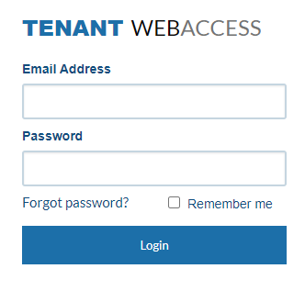
Once logged in you will see your tenant dashboard:
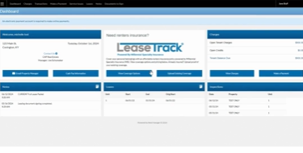
On the upper right side of the screen, you will see “make a payment” underneath tenant charges:
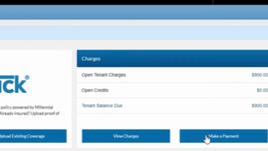

Then you will be taken to the screen to enter payment amount and source.
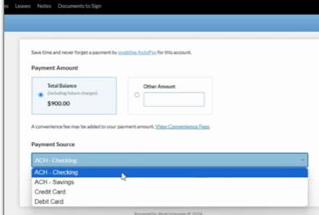
Once you select then you will hit “continue” and then you will go to the screen after that to enter info.
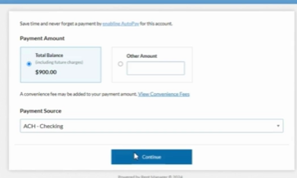
Here you enter your payment information:
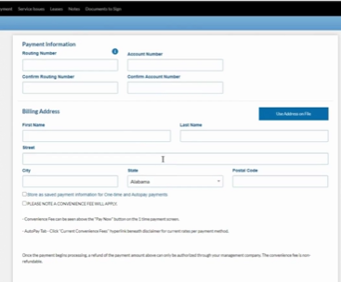

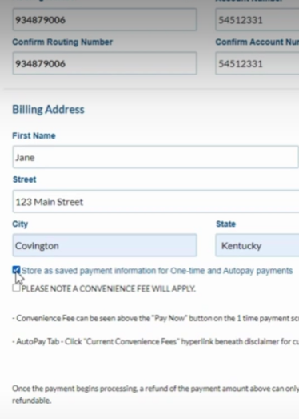

You will scroll down to the bottom of the screen and select “pay now.”
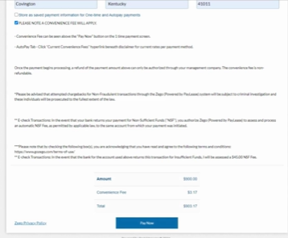
Your payment has been submitted!

