Trouble shooting your over the range microwave

Before calling in a work order on your over the range microwave please take these simple steps to ensure that it is working properly:

1. Check to make sure it is properly plugged in, and the circuit breaker is functioning (not a tripped breaker).
2. Make sure the door is fully closed and that the control panel is responding
3. Ensure that the microwave door is fully closed and latching properly.
4. If all of these check out then unplug the microwave, wait five minutes, then plug it back in to see if this reset the internal components.

The microwave will be plugged into the cabinet that is directly above it

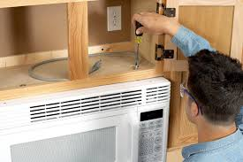

1. Make sure that there is not any food or other items blocking the turntable or vents.

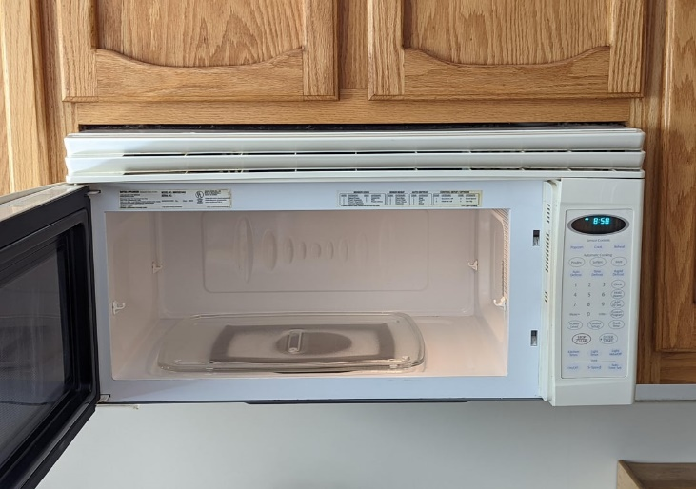

After all these steps and it is still not working, please take a video that is less than 90 seconds of what the microwave is doing (or isn’t). Also located the manufacturer (which can be found on the front of the microwave) as well as the model number. The model number can be found on the inside of the microwave when you open the door.

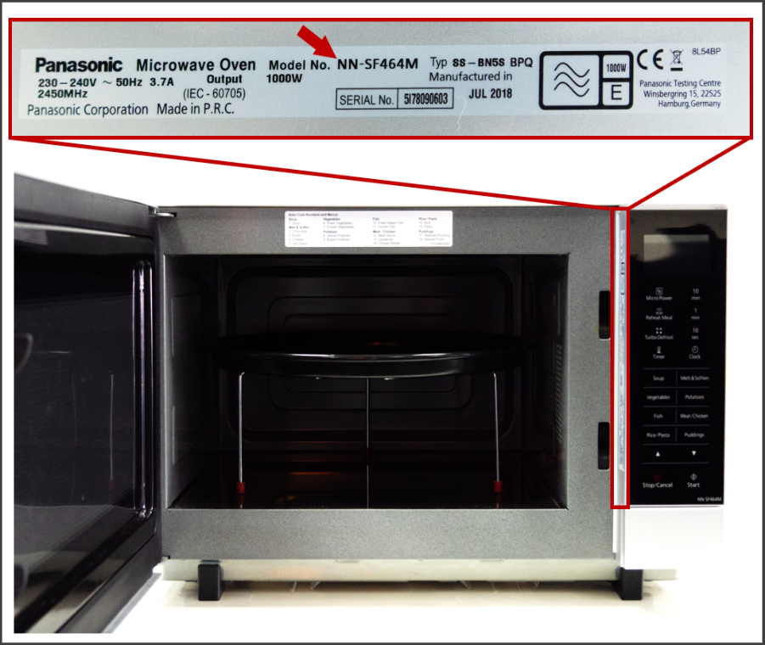

Thank you for your valued partnership with C.A.P.